Patrick Sullivan
27539851
ECE 697
Lab 1
Part A:
- See picture below. Note: from the initial state of 00 only 10 is reachable
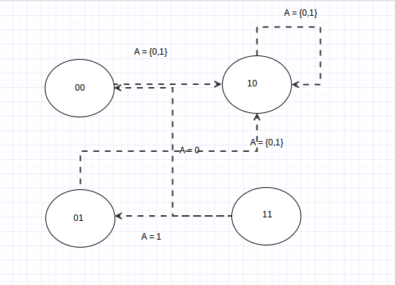
- My program for the explicit reachability uses a variation of depth first search. I essentially step through a truth table of inputs that then checks whether or not a new state is reachable with the current state of inputs. If there is one it then adds the new state to a dictionary of new states to be explored. If the state already exists in the visited dictionary or the to be explored dictionary it will ignore that calculated state. Once the program steps through the truth table for that state it will remove the current state entry from the to be explored dictionary and add the entry to the visited dictionary. If the truth table is stepped through and the to be explored dictionary is empty then there are no new states to be explored so the possible set of reachable states has been exhausted. I keep track of all states and nodes using the dictionary data structure in python which has a 0(1) run time.
The total number of states is 2^(the number of DFF's) and for each of these states you are doing 2^(inputs) for the truth table. Also you must calculate n nodes for the program. So the big O analysis is n*2^(number of DFF's)*2^(number of inputs)
Pseudo Code:
while still searching{
for each entry in the truth table{
calculate next state()
if newState has not been seen:
add to toBeExplored
if targetState == calculated state
done target found
}
pop tobeexplored
current state = top of to be explored
}

Test Bench | Target State | Result
Ex1.testbench | None provided
Ex2.testbench | 111111111111111 | Not found
Ex3.testbench | 10000011000001101101000000000 | Timed out
Ex4.testbench | 00000001000000000000000000000000 | Timed out

- See attached files and intructions.txt
Part B:

CNF Reachability with two unrolls with ex1.bench (Assumed that second state means two transitions)
State | Reachable | If Reachable Solution
00 | UNSATISFIABLE
01 | UNSATISFIABLE
10 | SATISFIABLE | v 1 -2 3 -4 -5 -6 -7 8 -9 10 11 -12 -13 -14 0
11 | UNSATISFIABLE

Program | Satisfiable in 10 Unrolls
ex2.bench | UNSATISFIABLE
ex3.bench | SATISFIABLE
ex4.bench | UNSATISFIABLE

To measure the run time of the programs I ran the execution in the terminal as date; command ; date and then compared the difference in time

Program | Execution Time Seconds For Exhaustive Reachability | Execution Time Seconds For Picosat Solver
ex1.bench | 0 | 0.0
ex2.bench | 268 | 0.0
ex3.bench | 600 (Timeout) | 0.0
ex4.bench | 600 (Timeout) | 0.0

As seen the picosat SAT solver is much faster than the exhaustive search algorithm. There are several limitations to not checking whether the condition is satisfied in the intermediate unrolls. If your testing for reachability you might miss the target state and conclude that the state is unreachable even though it was reachable in previous steps. One way to avoid this issue would be to run the program in a loop which progressively unrolls the equations incrementally, so that you can have reasonable confidence in the reachability of the target state. Programs like bash are quite good for this.

- Code is attached

- Here is the graph for part five.

